Unified Explainable AI Interface



Unified Explainable AI Interface 1
I. Introduction 3
a) Context and Motivation 3
b) Project Objectives 3
II. Analysis of Original Repositories 3
a) Deepfake Audio Detection Repository 3
b) Lung Cancer Detection Repository 3
c) Key Limitations and Integration Challenges 3
III. Deepfake Audio Detection Implementation 3
a) Audio Preprocessing and Spectrogram Generation 3
b) Model Pipeline and Output 3
IV. Lung Cancer Detection Implementation 3
a) Image Preprocessing 3
b) Model Inference Pipeline 3
V. System Architecture and Deployment 3
a) Microservices Architecture 3
b) Service Communication and API Design 3
c) Containerization and Deployment Strategy 3
VI. Explainable AI Integration 3
a) Overview of Selected Methods 3
b) Output Analysis 5
c) Why Use Three XAI Methods ? 5
VII. Frontend Implementation 6
VIII. Conclusion 7

Introduction

Context and Motivation
Deep learning models increasingly power critical applications, from medical diagnosis to media authenticity verification, yet their decision-making processes remain by definition opaque. Explainable AI (XAI) tries to address this difficulty by visualizing which features drive predictions, enabling domain experts to validate and trust model decisions. However, existing XAI implementations typically remain isolated: bound to specific data modalities, limited to single explanation methods, etc…

To show that it some XAI techniques are adaptable and scalable, this project tries to unify two distinct classification systems into a single XAI platform. The first component, deepfake audio detection trained on the Fake-or-Real dataset, was provided as a two-year-old Streamlit implementation. The second component, lung cancer detection from chest X-rays, was developed entirely from scratch for this project. Both systems required some architectural refactoring and XAI enhancement to enable unified deployment.

Project Objectives
Following the project requirements, this work delivers a unified platform with the following capabilities:
- Multi-modal input processing: Audio (.wav) and medical image support through drag-and-drop interface.
- Multiple model integration: Classification models for both deepfake detection, refactored from provided repository and lung cancer detection, developed from scratch, adapted to produce a common output format to efficiently connect to the XAI interface.
- Comprehensive XAI implementation: Integration of three explainability methods: Grad-CAM, LIME and SHAP.
- Production-ready architecture: Complete refactoring from monolithic Streamlit to modular microservices, containerization with Docker and orchestrated deployment for reproducibility, with the step-by-step method precisely defined within the Readme of the project.

The platform serves as both a functional classification tool and an educational instrument for understanding how different XAI approaches, gradient analysis, perturbation sensitivity and coalitional game theory, provide distinct and complementary informations on neural network decision-making.

Analysis of Original Repositories

Deepfake Audio Detection Repository
The provided deepfake audio detection system was developed in 2024 as a Streamlit web application for binary classification of audio files using the Fake-or-Real dataset. The implementation consisted of a monolithic script that coupled audio preprocessing, model inference and XAI visualization within a single namespace.
The original codebase implemented two XAI methods: Grad-CAM and LIME. The architecture employed entirely procedural functions with no object-oriented design, hardcoded file paths and no separation between business logic and presentation layer.
The technical stack relied on TensorFlow 2.6.2 and Python 3.9, versions that present compatibility challenges with modern development environments. No containerization was provided, and the exact dependency specifications created version lock-in that complicates deployment on current systems.

Lung Cancer Detection Repository
No existing code was provided within the lung cancer detection repository. This component was developed entirely from scratch by ourr team to demonstrate XAI cross-modal applicability. The pipeline was designed to mirror the deepfake system's structure: binary classification (cancer/no-cancer), standardized 224×224×3 input format and identical XAI method interfaces.
Implementation involved selecting appropriate chest X-ray datasets, adapting pretrained CNNs through transfer learning and implementing precise preprocessing for this type of data, like grayscale-to-RGB conversion or medical image normalization.

Key Limitations and Integration Challenges
Both systems presented some obstacles necessitating some architectural redesigns:

- Version compatibility: The deepfake repository's TensorFlow 2.6.2 dependency is incompatible with Python 3.10+, preventing execution on modern environments. Locked dependencies created deployment constraints. Without containerization, developers faced cryptic dependency conflicts during manual environment configuration.

- Unusable legacy codebase: The monolithic app.py featured hardcoded paths requiring manual directory setup. No error handling existed and incompatible uploads caused silent failures. Minimal documentation beyond "run streamlit" forced us to reverse-engineer the requirements.
- Non-standardized outputs: The deepfake system returned raw numpy arrays while lung cancer models needed structured outputs with predictions, confidence scores, etc. XAI visualizations similarly diverged, requiring common interfaces neither system anticipated.
- Architectural Incompatibility: Streamlit's reactive model conflicts with RESTful design. No production infrastructure existed: no logging, input validation, health checks or error handling.
With all these limitations and challenges acknowledged, we choose to use a container-oriented solution for this project.

Deepfake Audio Detection Implementation

Audio Preprocessing and Spectrogram Generation
The deepfake detection pipeline transforms raw .wav audio files into visual representations suitable for CNN classification through a multi-step preprocessing chain implemented in the AudioDetectorModel class.
Input audio files are loaded using librosa's default configuration, which automatically resamples to 22050 Hz regardless of the original file's sampling rate. This standardization ensures consistent temporal resolution across diverse audio sources.
The core transformation then converts the one-dimensional audio signal into a two-dimensional MEL spectrogram using librosa.feature.melspectrogram with default parameters. These defaults specify 128 MEL-scale frequency bands a hop length of 512 samples and frequency range from 0 Hz to the Nyquist frequency, meaning 11025 Hz for 22050 Hz sampling rate. The resulting power spectrogram undergoes logarithmic compression via librosa.power_to_db, converting to decibel scale to enhance visibility of subtle acoustic features distinguishing real from synthetic audio.
The MEL spectrogram matrix is rendered as an image using matplotlib with librosa's display.specshow(), applying the default viridis colormap that maps spectral power to color intensity: dark regions indicate silence and bright regions indicate high energy. The visualization is saved to a temporary PNG file via tempfile.NamedTemporaryFile(), ensuring automatic cleanup after processing.
The saved spectrogram is reloaded using Keras' load_img() with forced resizing to the class constant TARGET_SIZE = (224, 224), applying bilinear interpolation to match standard CNN input dimensions. The final output is a 224×224×3 RGB tensor that is normalized to [0, 1] range via division by 255.0 and expanded to batch dimension (1, 224, 224, 3) ready for model inference.
- Model Pipeline and Output
The classification model is loaded from a TensorFlow SavedModel directory during service initialization (tf.keras.models.load_model(model_path)). The exact CNN architecture remains abstracted: our implementation treats it as a black box accepting (1, 224, 224, 3) float32 tensors and producing binary classification probabilities.
The preprocessed spectrogram tensor is passed through the model's predict() method, which returns a 1 by 2 shaped array containing softmax probabilities for classes ["real", "fake"]. We extract the predicted class via np.argmax(prediction[0]) and the associated confidence score as the maximum probability value prediction.
Results are encapsulated in a Pydantic AudioPrediction model, ensuring type safety and validation. This structured format enables consistent API responses, frontend display and provides metadata required by XAI methods.

Lung Cancer Detection Implementation

Image Preprocessing
The lung cancer detection pipeline processes chest X-ray images using TorchXRayVision, a library specialized for medical imaging, implemented in the LungDetectorModel class.
Images are loaded via skimage.io.imread(), supporting various formats (JPEG, PNG, DICOM). RGB images (3-channel) are converted to grayscale by averaging across color channels, producing a 2D array suitable for medical imaging models.
The preprocessing creates two parallel representations: a model input image undergoing full TorchXRayVision normalization, and an explainable image preserved in [0,1] range for XAI visualization. Both are initially normalized by dividing by 255.0 if needed.
The model input undergoes z-score normalization via xrv.datasets.normalize(), applying ImageNet-adapted statistics for medical X-rays. Both images are then processed through XRayCenterCrop() to removes the borders and XRayResizer(224) to resizes to 224×224 pixels.
The model input is converted to a PyTorch tensor with shape [1, 1, 224, 224], while the explainable image remains as a NumPy array [224, 224] for XAI processing.

Model Inference Pipeline
The system uses TorchXRayVision's DenseNet model, loaded in evaluation mode and moved to the detected device (CPU or CUDA). The system then extracts the score for "Lung Lesion»: scores superiors to 0.5 produce "Cancer suspected" whwile scores inferior to 0.5 produce "No cancer detected".
Results use a Pydantic LungPrediction model exposing both the raw model score and threshold, providing transparency.

System Architecture and Deployment

Microservices Architecture
To address the limitations of the original monolithic Streamlit implementation, the system was redesigned using a microservices architecture. The platform is now composed of three independent services: a deepfake audio detection backend, a lung cancer detection backend and a unified frontend application. Each service is containerized and deployed independently, ensuring a clear separation of concerns.
This design resolves the fundamental incompatibility between the two detection pipelines. The deepfake audio system relies on legacy dependencies such as TensorFlow 2.6.2 and Python 3.9–compatible libraries, while the lung cancer detection system uses a modern PyTorch-based stack. By isolating each backend within its own Docker container with pinned dependencies, version conflicts are eliminated. Additionally, this separation allows each service to implement modality-specific preprocessing and inference logic, reducing code complexity and improving maintainability compared to a single monolithic application.

Service Communication and API Design
Inter-service communication is implemented through RESTful HTTP APIs. The frontend serves as the only user-facing component, while backend services remain internal to the Docker network. An Nginx reverse proxy embedded in the frontend dynamically routes requests to the appropriate backend based on URL path patterns, enabling transparent service selection according to the user’s chosen detection modality.
Both detection backends expose structured FastAPI endpoints. The deepfake audio detection API accepts audio files and an explainability method selection and returns prediction results, confidence scores, processing time and visual explanation outputs encoded in base64. The lung cancer detection API follows a similar design, adapted to medical image inputs and multi-label predictions. All responses are defined using Pydantic models, ensuring consistent validation, type safety and JSON serialization across services despite differences in underlying frameworks.

Containerization and Deployment Strategy
Each service is containerized using a dedicated Dockerfile that specifies exact dependency versions. This isolation strategy directly resolves the dependency conflicts identified in earlier system iterations.
Docker Compose is used to orchestrate the multi-container setup, defining a custom bridge network that enables secure inter-service communication. Only the frontend exposes a port to the host system, enforcing a gateway pattern that prevents direct external access to backend services.
Both backend containers optionally support NVIDIA GPU acceleration for model inference, with graceful fallback to CPU execution when GPU resources are unavailable. A separate development configuration enables hot-reload and direct API access for testing while preserving a production-like deployment structure.

Explainable AI Integration

Overview of Selected Methods
The platform integrates three complementary Explainable AI (XAI) methods, Grad-CAM, LIME and SHAP, chosen for their fundamentally different approaches to model interpretation.
Grad-CAM uses gradient information within convolutional neural networks to identify spatial regions that most influence the predicted class. By weighting feature maps of the final convolutional layer with class-specific gradients, it produces coarse heatmaps highlighting discriminative regions. This method requires access to model internals but is computationally efficient.

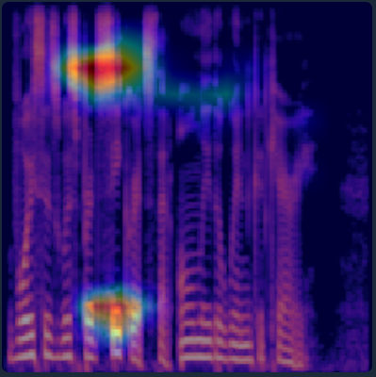
Figure 1 : Grad-CAM for Deepfake Detection
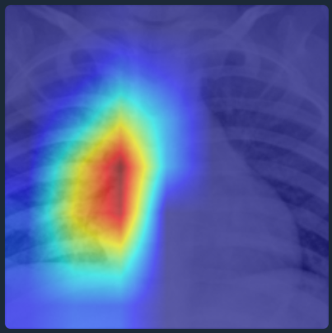
Figure 2 : Grad-CAM for Cancer Detection

LIME treats the model as a black box and explains predictions through local perturbations. The input image is segmented into superpixels, which are randomly masked to generate perturbed samples. A local linear model is then fitted to approximate the classifier’s behavior around the original input, identifying regions that support or oppose the prediction. LIME is model-agnostic but computationally more expensive.

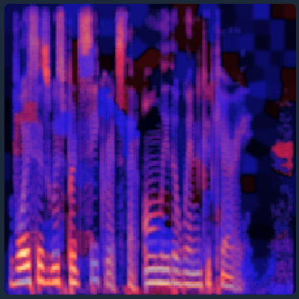
Figure 3 : LIME for Deepfake Detection
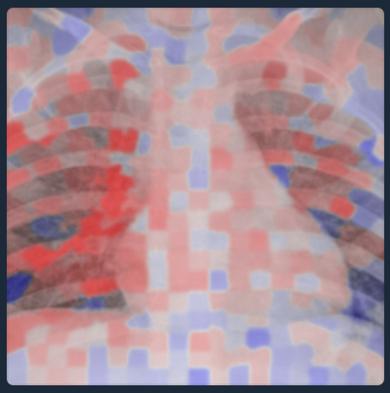
Figure 4 : LIME for Cancer Detection

SHAP is based on game theory and assigns a contribution score to each region of the input, showing how much it influences the model’s prediction. For images, these contributions are estimated by testing different combinations of image regions. Although this method is computationally expensive, it provides reliable and mathematically well-founded explanations.
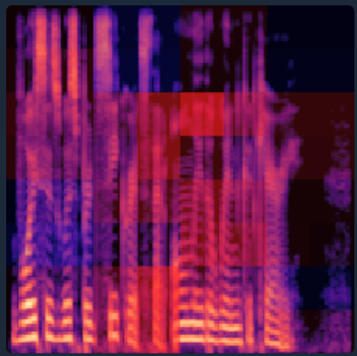
Figure 5 : SHAP for Deepfake Detection

Output Analysis
Each method produces distinct visual explanations reflecting its underlying principles. Grad-CAM generates smooth heatmaps highlighting regions of high model sensitivity, such as specific frequency-time patterns in audio spectrograms or suspicious anatomical regions in chest X-rays. LIME produces irregular, superpixel-based visualizations, where colors indicate regions that support or contradict the prediction. SHAP outputs grid-like patch attributions, with positive and negative contributions clearly separated and additive by construction.
Comparing these outputs provides insight into model behavior. Convergence across methods suggests robust and consistent reasoning, while divergence may indicate reliance on multiple features, spurious correlations, or model instability.

Why Use Three XAI Methods ?
Using three XAI techniques provides complementary perspectives that no single method can offer alone. Grad-CAM inspects internal gradient flow, LIME probes external input-output behavior and SHAP delivers principled attributions. This diversity reduces the risk of misleading explanations and increases trustworthiness.
The methods also offer practical trade-offs: Grad-CAM enables fast analysis, LIME provides intuitive explanations accessible to everyone and SHAP offers rigorous justifications suited for high-stakes domains. Their varying spatial granularities further enhance interpretability.
As you can see in the screenshots, having three XAI models can also be used to compare the results.

Frontend Implementation
The frontend provides a unified user interface that abstracts the underlying multi-backend architecture while offering intuitive access to classification and explainability features. It is implemented as a static single-page application, prioritizing simplicity, performance and ease of deployment over the use of heavy frontend frameworks.
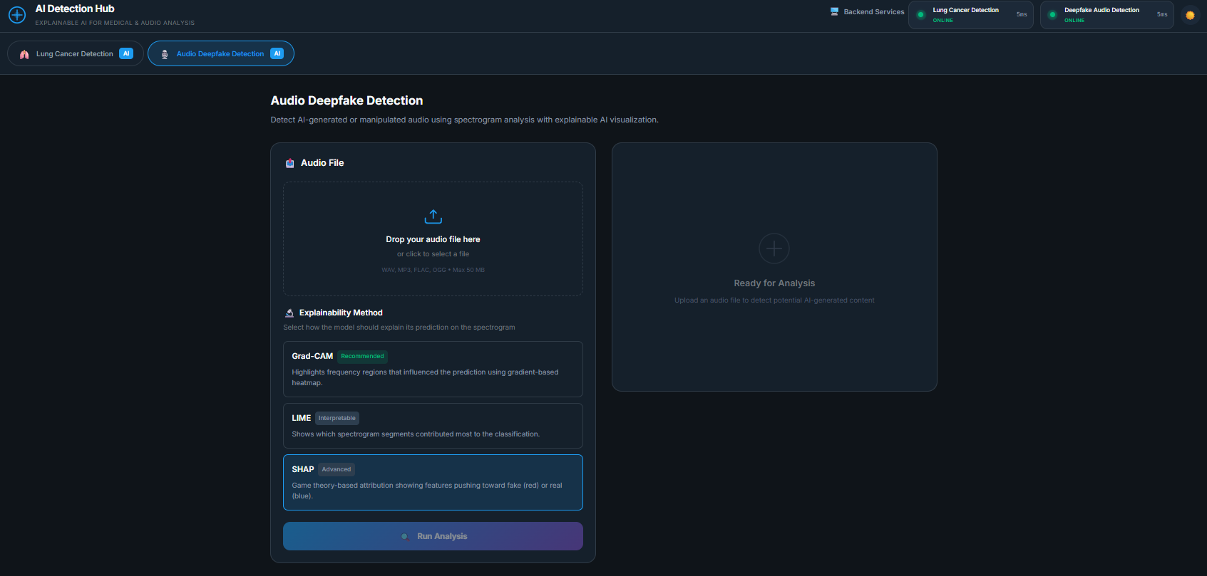
The application is built using vanilla HTML, CSS and JavaScript, organized into modular directories separating UI components, API services, view logic and core state management. This structure maintains readability and scalability without introducing dependencies on frameworks such as React or Vue. Static files are served through an Nginx Alpine container, which also handles reverse proxying to backend services. Docker-based DNS resolution enables dynamic service routing without hardcoded addresses.
Users access the platform through a single entry point and begin by selecting the analysis modality, either deepfake audio detection or lung cancer detection. This choice dynamically adapts the interface: accepted file formats are updated accordingly, available XAI methods are filtered to ensure compatibility and requests are automatically routed to the appropriate backend service.
File upload is handled via a drag-and-drop interface with client-side validation of format and size. Files are sent to the backend using multipart form-data requests routed through Nginx. The frontend provides real-time feedback on upload status and displays clear error messages in case of invalid inputs or network failures.
Explainability methods are selected directly within the menu. Classification results are displayed in structured panels showing the predicted label, confidence score and processing time. XAI outputs are rendered as decoded PNG heatmaps alongside the original input, with color legends clarifying attribution semantics.
Note that by delegating computation entirely to backend microservices and serving static assets through Nginx, the interface remains lightweight and scalable.

Conclusion
This project demonstrates the successful integration of two initially independent XAI systems, a deepfake audio detector and a lung cancer classifier, into a unified, multi-modal and interpretable AI platform. By transitioning from a monolithic Streamlit implementation to a microservices architecture based on containerized FastAPI backends, major dependency conflicts were resolved while enabling modularity, scalability and maintainability.
The use of three complementary explainability methods, Grad-CAM, LIME, and SHAP, provides diverse and mutually reinforcing insights into model behavior. Comparing explanations across these methods helps identify consistent decision patterns as well as potential instabilities or biases.
Overall, the project underlines the importance of combining robust system architecture with explainable AI methods to build reliable, transparent and extensible AI applications suitable for critical real-world domains.

Disclosure of Generative AI Usage
This project involved the use of Generative Artificial Intelligence tools (ChatGPT and Claude) to assist with code refactoring, debugging, and conceptual clarification.
The AI tools were used strictly as support. All core ideas, system design, implementation decisions, training procedures, evaluation, and interpretations were performed and validated by the project team.

